**Flying Enemy Controller**

**Attack Behaviour**

This part of the flying enemy script will allow the enemy to attack the player and switch to the retreat state behaviour after the attack or if the attack is not successful. The attacking behaviour will act as follows. The enemy will fly to the current position of the target at a high speed and stop when it gets to that position.

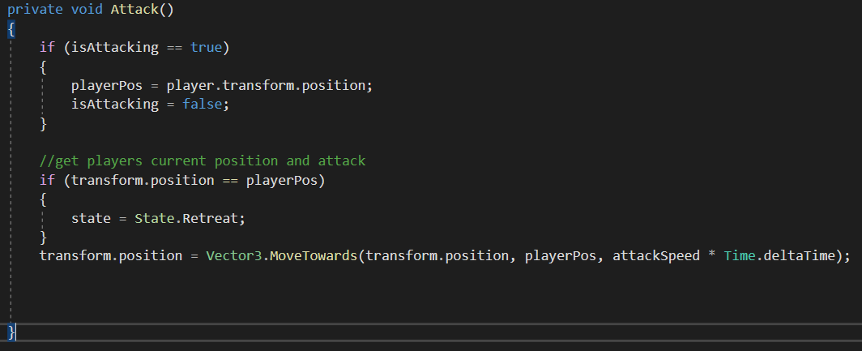

The first part of the attacking behaviour is getting the players position at the time the behaviour switches to attacking. It is important that the target position that is set is only set once. This ensures the enemy does not follow the player but instead goes to the place the player was previously at.

This is achieved by using a Boolean. While the Boolean is true the target of the attacking enemy is set to the current position of the player. The Boolean is set to false straight away one the target position is set. By doing this the only time the target position can be reset is when the enemy attack again.

Once the enemy has a target location to go to you can manipulate the transform of the enemy using vectors to move it to the target position. It is important that every frame the position of the enemy is check as it could be at the target position. To do this there is a conditional statement used to check the enemy’s position. If the position is the same as the target position then the enemy’s state is changed to retreat.

**Retreat Behaviour**

This part of the flying enemy script will allow the enemy to retreat from the player after attacking. This method checks if the enemy has reached its target location which is set to the point in the world where it spawned. If it has reached that set location then it’s behaviour is switched to “idle”.

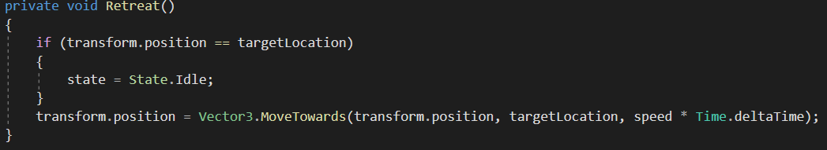

The first part of this method is the conditional statement that checks if the enemies current position is at the set target location, where the enemy spawned. If said condition is true then the enemy’s behaviour is set to “idle”.

The final part of this method is moving the enemy to its target position. Every frame that the retreat behaviour is set as the active behaviour the enemy will move towards the target location.

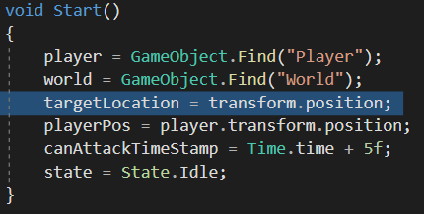

The target location is set to the enemies position within the Start method. This method is called once as soon as the enemy is spawned in.

**Taking damage and death**

This section of the script allow the enemy to take damage and if enough damage is taken then the enemy will die.

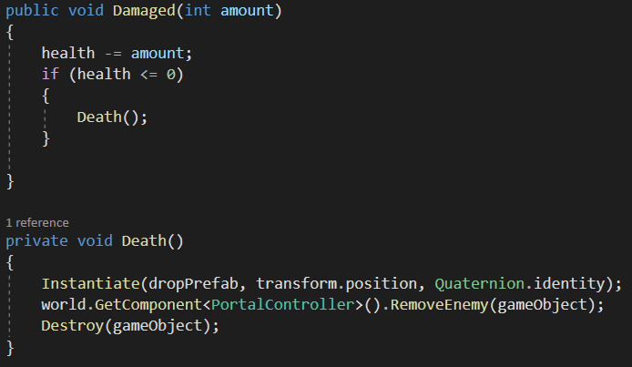

The first method is allows the enemies health to be decreased while also checking if its health is low enough to call the death method. By accepting an integer in the methods perameters whatever damaged the enemy can do any amount of damage. The amount passed through the method is subtracted from the enemies current health variable. A conditional statement is then used to check if the enemies health is less than or equal to 0. If so, the death method is called.

When the death method is called a prefab is instantiated at the current position of the enemy, this is the item it drops when it dies. Finally the enemy is removed from the scene using the destroy fuction.

**Collisions**

This part of the script will handle any collisions the enemy has. Within the built in method OnTriggerEnter(). You can get information about what was collided with using the paramaters (Collider other).

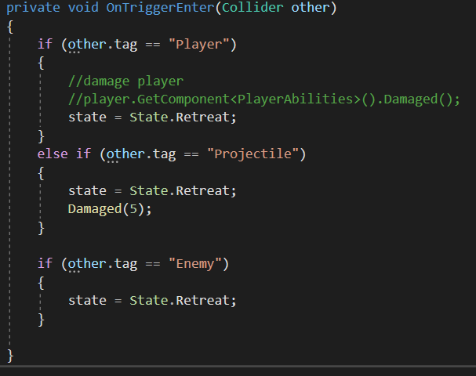

For the enemy to know what behaviour state to use, we can check if it collided with an object that has been assigned the tag “Player” for example. We can then do State = State.BEHAVIOUR to set the enemy’s behaviour.